Charting the Course of Innovation: A Startup Analysis

INTRODUCTION

OVERVIEW

A startup is a company that's in the initial stages of business. Founders normally finance their startups and may attempt to attract outside investment before they get off the ground. Funding sources include family and friends, venture capitalists, crowdfunding, and loans. To Extract the insights from the data and put the data in the from of visualization, Dashboard and story we employed tableau tool.

Starting a new company can be an exciting and rewarding experience, but it also requires careful planning and analysis to ensure that the business is viable and successful. There are several key areas that you should focus on when conducting a startup company analysis. Conducting a thorough analysis of these areas can help you identify potential challenges and opportunities, and develop strategies to address them. It is also important to regularly review and update your analysis as the business progresses, in order to adapt to changing market conditions.

PURPOSE

A startup financial analysis is a process by which a company can assess its financial health and performance. This type of analysis can be incredible important for early-stage companies, as it can help them identify areas of improvement and make sound decisions about their future.The primary game is to answer market demand by creating new and innovative product or service.while most small businesses might intend to stay small, a startup focuses on fast growth into a viable product, service or platform

Starting a new company can be an exciting and rewarding experience, but it also requires careful planning and analysis to ensure that the business is viable and successful. There are several key areas that you should focus on when conducting a startup company analysis. Conducting a thorough analysis of these areas can help you identify potential challenges and opportunities, and develop strategies to address them. It is also important to regularly review and update your analysis as the business progresses, in order to adapt to changing market conditions.

Problem definition and Design Thinking

Empathy Map

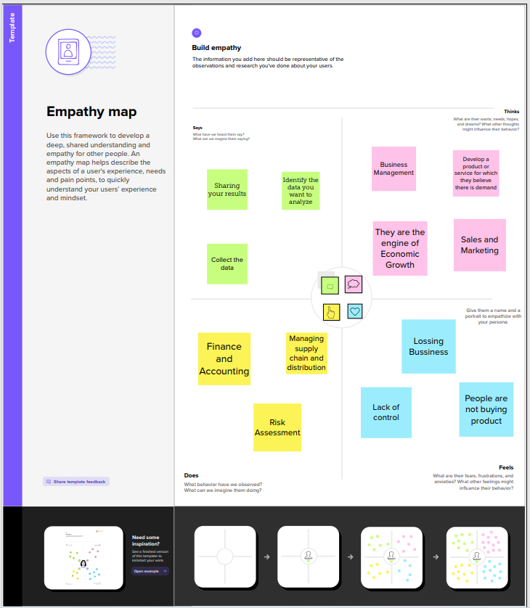

Ideation & Brainstoming Map

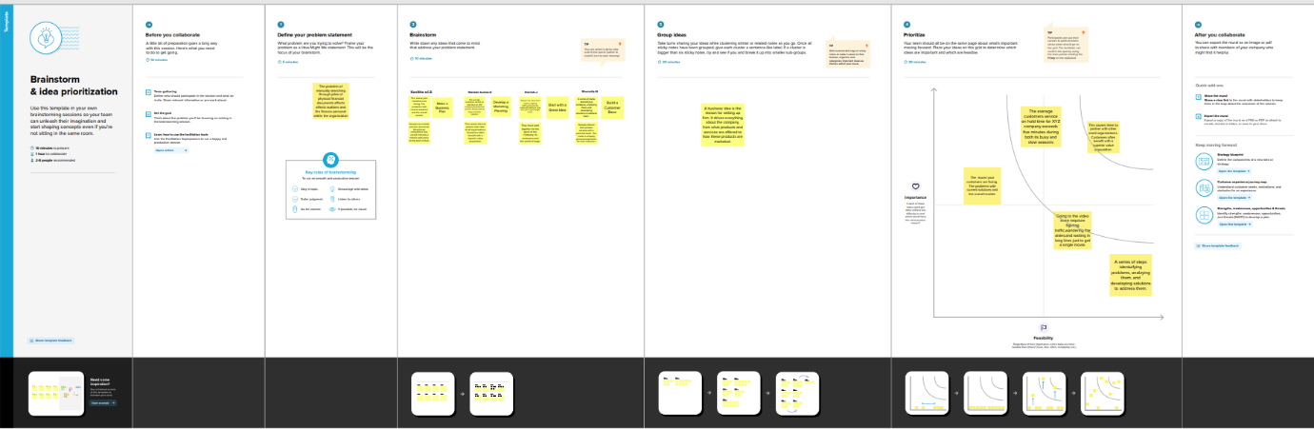

RESULT

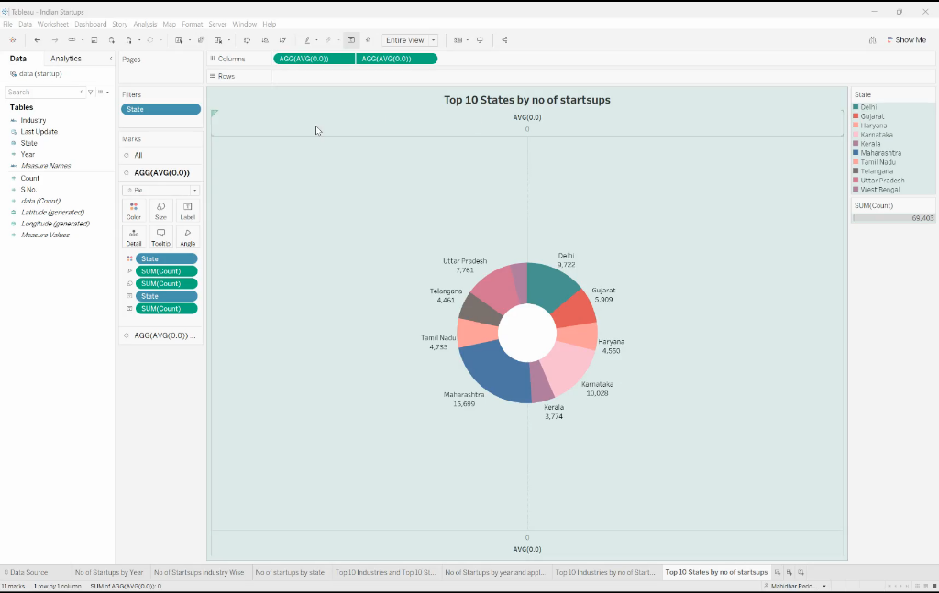

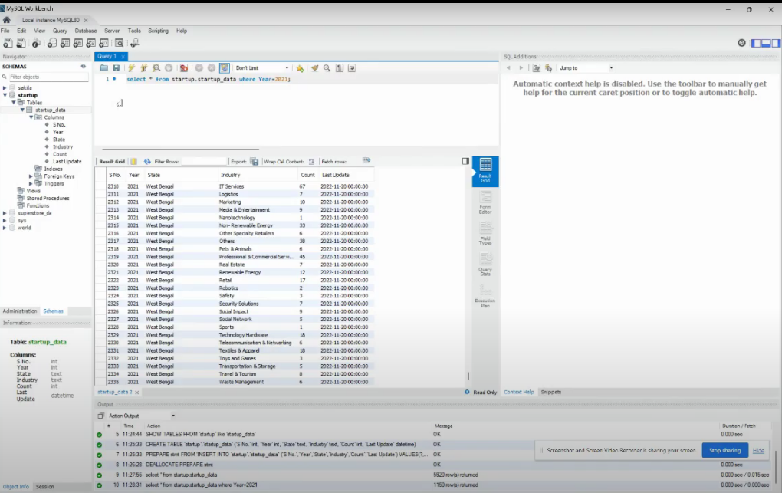

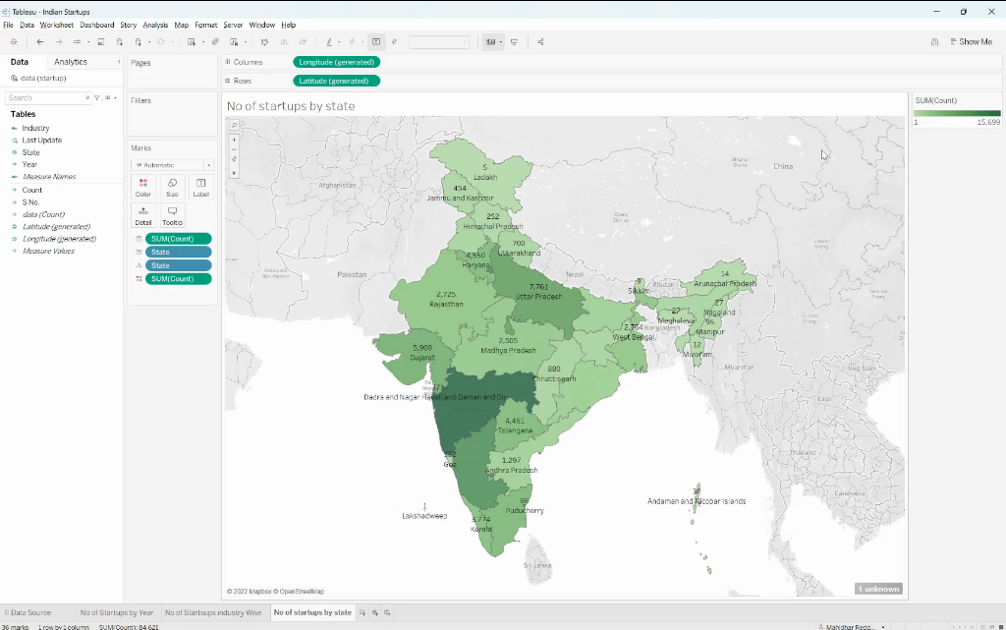

Advantages & Disadvantages

1.Advantage

**Freedom and Flexibility**

* When you own a business, you are your own boss. This means that you decide your schedule, call the shots for your business, and get to create a business that is unique to your vision.
* Forget the typical nine-to-five day job — as a business owner, your time isn’t dictated by punching a clock. Instead, you get to dedicate your time to a project you’re passionate about that is centered around your business goals and ambitions.

**Creativity**

* As the founder, your startup is based on your vision. This means you have the opportunity to get creative in your approach and really see your ideas come to life.
* Whether you’re in a creative industry or not, entrepreneurship by its nature encourages a creative perspective towards everything from the startup idea to daily problem-solving.
* Not to mention, you have the final say over branding and marketing materials – giving you the opportunity to put your artistic side to work.

**Valuable Relationships**

* Networking is a huge part of startup ownership. While this may sound a little daunting, networking with other entrepreneurs, founders, and professionals can result in a community of motivated individuals who inspire you.
* Not only does this benefit you professionally, but surrounding yourself with a network of passionate, motivated people can also benefit your personal life and help you grow as an individual.

**Personal Growth**

* As an entrepreneur, you will almost certainly be required to overcome challenges that will test you. These hurdles, in many ways, are blessings in disguise.
* The challenges you face as an entrepreneur will contribute to your professional growth and help you evolve personally.
* From fine-tuning your communication skills to better manage staff and strengthening your problem-solving abilities, many of the lessons you will learn as an entrepreneur will manifest in a positive way through your personal life as well.

**Positive Impact**

* As a startup founder, you have the opportunity to make a positive impact on your community and the world around you regardless of the type of startup you’re founding.
* Whether you’re a [**social entrepreneur**](https://startupsavant.com/what-is-a-social-entrepreneurship-startup) or simply prioritize incorporating equitable company practices that contribute to the betterment of society, you have the authority to use your position to do good.

2. Disadvantage

### Long Hours

* Being your own boss means you get to make your own schedule. However, as a business owner, you should anticipate working longer hours than you would at a typical nine-to-five job.
* A huge part of [**being an entrepreneur**](https://startupsavant.com/entrepreneur-anatomy) is being willing to dedicate yourself and your time to maintaining and growing your business. This means less time spent on your hobbies and with friends and family, which is a dealbreaker for some entrepreneurs that cannot commit this much time.

### Stress and Uncertainty

* Launching your own startup poses inherent risks, including a degree of uncertainty even for the most well-planned businesses.
* Therefore, adaptability and resilience are critical traits for an entrepreneur to be able to combat the stress and uncertainty of founding a startup.
* As a cornerstone of entrepreneurship, it's a good idea to consider the level of stress and uncertainty you’re confident handling before launching your own startup.

### Self-Doubt

* There is a level of confidence that you need to have in order to start and maintain a successful startup. Most entrepreneurs will experience self-doubt to some capacity when they start their own business.
* Understandably, there is a great deal riding on their vision, leadership, and business savvy. As one of the cons of launching a startup, an entrepreneur's ability to persevere through bouts of self-doubt and potential failures is crucial.

### Financial Risk

* Whether you’re [**bootstrapping a startup**](https://startupsavant.com/tips-for-bootstrapping-your-startup) using your own personal savings or partnering with an investment firm that expects a high return on their investment, founding a startup requires unavoidable financial risk.
* While financial risk can be mitigated somewhat by business planning and financial forecasting, there is no way to eliminate financial risk completely. Therefore, before you start a startup of your own, you should be absolutely sure that you are comfortable taking on the financial risk.

APPLICATIONS

Tableau is basically a data visualization tool which provides pictorial and graphical representations of data. In Tableau ,you can gain insights that you never thought possible.You can play with interactive visualizations,deploy data drilling tools and explore various data that is available and with tableau ,it is all about an easy and interactive approach.

MySQL is a relational database management system based on SQL Structured Query Language.The application is used for a wide range of purposes, including data Warehousing e-commerce,and logging applications.

CONCLUSION

From this we can learned briefly about the tableau how can use it and its Applications .We can understand the team work importance,understanding and knowledge capacity. We are learned more about Business requirements ,Data collection,social impacts,SQL operators ,Data preparation,data Visualization and Dashboard.

FUTURE SCOPE

The demand for Data visualization is increasing rapidly and businesses are gaining a huge advantage since it allows them to get actionable insights in very little time so Tableau is most used software for data visualization.This Software provides rapid visualizations and as a result, it helps businesses to make decisions quickly.This project is very useful to my future courier .So thank you for Naan muthalvant

APPENDIX

